Motion - 01
CLASS 09 - SCIENCE

 | Section A
1 | The displacement of a body is proportional to the cube of the time lapsed. The magnitude of the acceleration is:  a) decreasing with time  b) increasing with time  c) constant  d) zero | [1]
2 | A ball is thrown up with a velocity of 20 ms$​^{−1}$ .What is the time of flight, neglecting air resistance?  a) 8 sec  b) 1 sec  c) 2 sec  d) 4 sec | [1]
3 | The area below v - t graph is a measure of:  a) Angular speed  b) Displacement  c) Angular acceleration  d) Acceleration | [1]
4 | The speed of a train increases at a constant rate a from zero to v, and then remains constant for an interval, and finally decreases to zero at a constant rate p. If L be the total distance travelled, then the total time taken is  a) $\frac{L}{v}+\frac{1}{v}\left(\frac{1}{α}+\frac{1}{β}\right)$  b) $\frac{L}{v}+\frac{v}{2}$ $\left(\frac{1}{α}+\frac{1}{β}\right)$  c) $\frac{L}{v}+\frac{2}{v}\left(\frac{1}{α}+\frac{1}{β}\right)$  d) $\frac{L}{v}+2v\left(\frac{1}{α}+\frac{1}{β}\right)$ | [1]
5 | Equation of motion can be used for a body having:  a) uniform acceleration  b) non - uniform acceleration  c) uniform motion  d) non - uniform motion | [1]
6 | A body moving in a circle of radius r covers$\frac{3}{4}$ th of the circle. The ratio of the distance to displacement is:  a) 3 :$2\sqrt{2}$  b) $3π$ : $2\sqrt{2}$  c) $3\sqrt{2}$ : $2π$  d) $2\sqrt{2}$ : $3π$ | [1]
7 | A man walks on a straight road from his home to a market 5.5 km away with a speed of 5.5 km h$​^{−1}$ . Finding the market closed he instantly turns and walks back with a speed of 7.5 km h $​^{−1}$ . What is the average speed and average velocity of the man between t = 0 to t = 104 min?  a) 6.36 km h$​^{−1}$ , 6.36 km h $​^{−1}$  b) 0, 6.36 km h$​^{−1}$  c) 0, 0  d) 6.36 km h$​^{−1}$ ,0 | [1]
8 | A boy runs for 10 minutes at a uniform speed of 9 kmh$​^{−1}$ . At what speed should he run for the next 20 minutes so that the average speed becomes 12 kmh $​^{−1}$ ?  a) 7.72 km h$​^{−1}$  b) 10.2 km h$​^{−1}$  c) 13.5 km h$​^{−1}$  d) 8.2 km h$​^{−1}$ | [1]
9 | If a moving body comes to rest, then it’sacceleration is:  a) Negative  b) Positive  c) Constant  d) Zero | [1]
10 | Usha swims in a 90 m long pool. She covers 180 m in one minute going either way. The average velocity is:  a) 30ms$​^{−1}$  b) zero  c) 180ms$​^{−1}$  d) 90ms$​^{−1}$ | [1]
11 | A dancer is demonstrating dance steps along a straight line. The position - time graph of the dancer is given here. 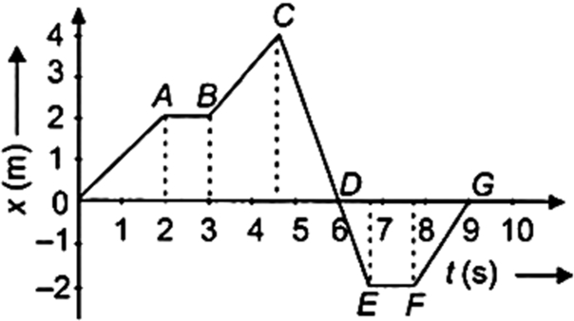  The average velocity of the dancer during time interval t = 2 s to t = 9 s is  a) 2.75 m s$​^{−1}$  b) - 0.29 m s$​^{−1}$  c) - 0.57 m S$​^{−1}$  d) 1 m S$​^{−1}$ | [1]
12 | A parachutist jumps off the plane and opens up the parachute at time t$​_{1}$ . He eventually reaches a steady speed and finally hits the floor at time t $​_{2}$ . Which of the following shows the speed - time graph of the parachutist’s descent?  a) 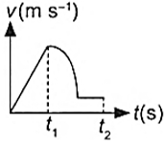  b) 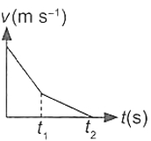  c) 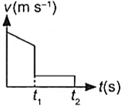  d) 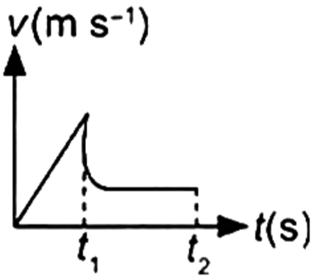 | [1]
13 | The numerical ratioof displacement to distance for a moving object is  a) always less than 1  b) equal or less than 1  c) always more than 1  d) always equal to 1 | [1]
14 | What does the slope of the position - time graph indicate?  a) Speed  b) Speed or velocity  c) Acceleration  d) Velocity | [1]
15 | Which of the following is the characteristic of distance travelled by an object?  a) It has only magnitude and no specific direction  b) It has a magnitude as well as specific direction  c) It can be zero  d) The distance travelled by an object is less than the magnitude of the displacement of the object. | [1]
16 | Slope of a velocity - time graph gives  a) The displacement  b) The acceleration  c) The distance  d) The speed | [1]
17 | The maximum speed of a train is 90 km/h. It takes 10 hours to cover a distance of 500 km. The ratio of its average speed to maximum speed is:  a) 9:5  b) 5:9  c) 1: 5  d) 5:1 | [1]
18 | Two cars A and B race each other. The Car A ran for 2 min at a speed of 7.5 km/h, slept for 56 min and again ran for 2 min at a speed of 7.5 km/h. The average speed of the car A in the race is:  a) 10 km/hr  b) 5 km/hr  c) 0.5 km/hr  d) 50 km/hr | [1]
19 | Two racing cars of masses m$​_{1}$ and m $​_{2}$ are moving in circles of radii r $​_{1}$ and r $​_{2}$ respectively. Their speeds are such that each makes a complete circle in the same length of time T. The ratio of angular speed of the first car to that of the second car is  a) r$​_{1}$ : r $​_{2}$  b) 1 : 1  c) m$​_{1}$ r $​_{2}$ , : m $​_{1}$ r $​_{2}$  d) m$​_{1}$ : m $​_{2}$ | [1]
20 | After jumping out from the plane, a parachutist falls 80 m without friction. When he opens up the parachute, he decelerates at 2 m s$​^{−2}$ . He reaches the ground with a speed of 4 m s $​^{−1}$ . How long did the parachutist spend his time in the air? (Take g = 10 m s $​^{−2}$ )  a) 18 s  b) 16 s  c) 4 s  d) 22 s | [1]
21 | Figure shows the x - t plot of a particle moving along a straight line. Let v$​_{1}$ and v $​_{2}$ be average speeds in time intervals 1 and 2 respectively. Then 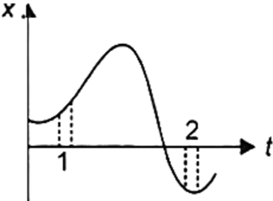  a) Data is insufficient  b) v$​_{1}$ = v $​_{2}$  c) v$​_{2}$ > v $​_{1}$  d) v$​_{1}$ > v $​_{2}$ | [1]
22 | For a uniformly accelerated body with initial and final velocities as u and v ms$​^{−1}$ , the average velocity is:  a) $\frac{u − v}{2}$  b) $\frac{v}{2}$  c) $\frac{u + v}{2}$  d) $\frac{u}{2}$ | [1]
23 | When a body moves uniformly along the circle, then: -  a) its speed changes but velocity remain the same  b) both speed and velocity changes  c) both speed and velocity remain the same.  d) its velocity changes but speed remain the same | [1]
24 | A particle is moving in a straight line with initial velocity u and uniform acceleration a. If the sum of the distances travelled in t$​^{th}$ and (t + 1) $​^{th}$ seconds is 100 cm, then its velocity after t seconds in cm s $​^{−1}$ is  a) 50  b) 80  c) 30  d) 20 | [1]
25 | A dancer is demonstrating dance steps along a straight line. The position - time graph of the dancer is given here. 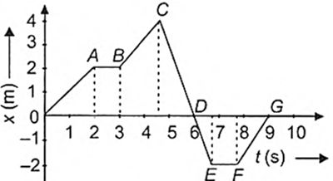  The average speed for the dance step depicted by CD is  a) 1 m S$​^{−1}$  b) 1.33 m S$​^{−1}$  c) 0.89 m S$​^{−1}$  d) 2.75 m S$​^{−1}$ | [1]
26 | Area under a v - t graph represents a physical quantity which has the unit  a) ms$​^{−1}$  b) M$​^{2}$  c) M  d) M$​^{3}$ | [1]
27 | A train moves from one station to another in two hourstime. Its speed - time graph during the motion is shown in figure. Identify the correct statement(s) regarding this graph. 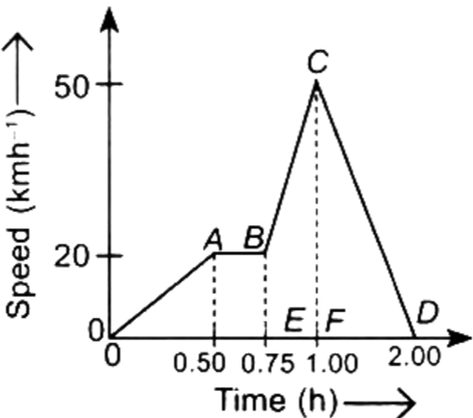  - The maximum acceleration during the journey is 120 km/h$​^{2}$ .  - The distance covered during the time interval from 0.75 hr to 1 hr is 8.75 km.  - During the time interval from 0 to 0.5 hrs, the train moves with constant velocity.  a) Only (i) is correct.  b) All (i), (ii) and (iii) are correct.  c) Only (ii) is correct.  d) Both (i) and (ii) are correct | [1]
28 | The displacement of the body can be -  a) Zero  b) All of these  c) Positive  d) negative | [1]
29 | What is the slope of the body when it moves with uniform velocity?  a) positive  b) zero  c) may be positive or negative  d) negative | [1]
30 | What does the slope of the velocity - time graph give?  a) acceleration  b) force  c) displacement  d) distance | [1]
31 | A body moving with uniform acceleration has velocities 20 ms$​^{−1}$ and 30 ms $​^{−1}$ . when passing two points A and B. Then the velocity midway between A and B is:  a) 25.5 ms$​^{−1}$  b) 24 ms$​^{−1}$  c) 25 ms$​^{−1}$  d) $10\sqrt{6}$ ms $​^{−1}$ | [1]
32 | A car travels 10 m in 5 seconds, 20 m in the next 10 seconds, and 30 m in the last 10 seconds. The average speed of the motion is:  a) 30 ms$​^{−1}$  b) 2.2 ms$​^{−1}$  c) 2.4 ms$​^{−1}$  d) 2.0 ms$​^{−1}$ | [1]
33 | A person sitting in the truck projected a ball vertically upwards. The ball:  a) falls outside the truck  b) falls by the side of truck  c) falls back in his hand  d) falls in front of the truck | [1]
34 | What does the area of the velocity - time graph give?  a) Displacement  b) Speed  c) Acceleration  d) Average speed | [1]
35 | Suppose a boy is enjoying a ride on a merry - go - round which is moving with a constant speed of 10ms$​^{−1}$ . It implies that the boy is  a) Moving with no acceleration  b) At rest  c) In accelerated motion  d) Moving with uniform velocity | [1]
36 | A signal from a space ship reaches the ground in 5 minutes. What was the distance of the space ship from the ground station? The speed of the signal is 3$×$ 10 $​^{8}$ m/s.  a) 9$×$ 10 $​^{7}$ m  b) 9$×$ 10 $​^{10}$ m  c) 9$×$ 10 $​^{6}$ m  d) 3$×$ 10 $​^{6}$ m | [1]
37 | If a body starts from rest, what can be said about the acceleration of the body?  a) Uniform accelerated  b) Positively accelerated  c) Negative accelerated  d) Non - Uniform accelerated | [1]
38 | What would you conclude about the variation in velocity of a cyclist from the given graph? 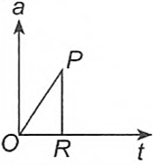  a) Velocity changes linearly if acceleration is changing non - linearly.  b) Velocity changes non - linearly if acceleration is changing linearly.  c) Velocity becomes uniform if acceleration becomes infinite.  d) Velocity becomes zero if acceleration becomes zero. | [1]
39 | A moving body is covering a distance directly proportional to the square of time. The acceleration of the body is:  a) constant  b) zero  c) increasing  d) decreasing | [1]
40 | Statement 1: Reducing the initial velocity to half the initial value, the stopping distance of moving object decreases by a factor of 2 (for the same deceleration). Statement 2: Stopping distance is proportional to the square of the initial velocity.  a) Both statements 1 and 2 are true but statement 2 is not the correct explanation of statement 1.  b) Both statements 1 and 2 are true and statement 2 is the correct explanation of statement 1.  c) Statement 1 is true but statement 2 is false.  d) Statement 1 is false but statement 2 is true. | [1]
41 | Which of the following is the characteristic of displacement of an object?  a) Displacement has only magnitude and no specific direction  b) The magnitude of the displacement is greater than the distance travelled by a moving object  c) Displacement has magnitude as well as specific direction  d) Displacement cannot be zero | [1]
42 | A ball is dropped onto the floor from a height of 20 m. It rebounds to a height of 10 m. If the ball is in contact with the floor for 0.1 seconds, what is the average acceleration during contact?  a) 142 m s$​^{−2}$  b) 338 m s$​^{−2}$  c) 564 m s$​^{−2}$  d) 285 m s$​^{−2}$ | [1]
43 | A particle is moving in a circular path of radius r. The displacement after half a circle would be  a) 2r  b) $2πr$  c) $πr$  d) zero | [1]
44 | A train starts from a station P and travels some distance with a uniform acceleration a$​_{1}$ ,then it goes with uniform retardation a $​_{2}$ for some more distance and come to rest at the station Q. If the distance between the stations P and Q is 4 km and the train takes 4 minutes to complete this journey, then $\frac{1}{a_{1}}+\frac{1}{a_{2}}$ =  a) 4 m$​^{−1}$ S $​^{2}$  b) 2 m$​^{−1}$ S $​^{2}$  c) 72 m$​^{−1}$ S $​^{2}$  d) 7.2 m$​^{−1}$ S $​^{2}$ | [1]
45 | If the v - t graph is a straight line inclined to the time axis, then:  a) a$≠$ 0  b) a = constant$≠$ 0  c) a$≠$ constant $≠$ 0  d) a = 0 | [1]
46 | A car accelerates uniformly from 18 km/h to 36 km/h in 5 sec. The acceleration is  a) 5 ms$​^{−1}$  b) 1 ms$​^{−2}$  c) 1 km/s$​^{2}$  d) 216 ms$​^{−2}$ | [1]
47 | A body is said to be in rest when:  a) Its position doesn’t change with time with respect to the observer.  b) It’s position changes with time w.r.t observer.  c) The body moves in uniform motion, w.r.t observer.  d) None of these. | [1]
48 | Two identical balls are at rest side by side at the bottom of a hill. Sometime after ball A is kicked up the hill, ball B is given a kick up the hill. Ball A is headed downhill when it passes ball B headed up the hill. At the instant when ball A passes ball B, it has the same  a) Position and acceleration as ball B  b) Position and velocity as ball B  c) Displacement and velocity as ball B.  d) Velocity and acceleration as ball B | [1]
49 | Which of the following is the position - time graph for a body at rest?  a) 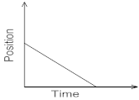  b) 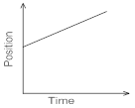  c) 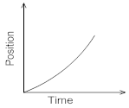  d) 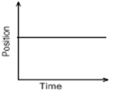 | [1]
50 | A body starting at a point, say A, reaches, say B, ahead in a straight line and returns back to A. Then there is:  a) negative displacement  b) cannot be said  c) zero displacement  d) positive displacement | [1]
51 | Which of the following figures represent uniform motion of moving object correctly?  a) 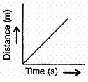  b) 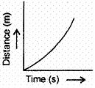  c) 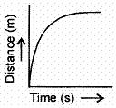  d) 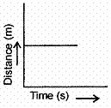 | [1]
52 | Which of the following gives both direction and magnitude?  a) Unit Scalar  b) Scalar  c) Unit Vector  d) Vector | [1]
53 | If the displacement of an object is proportional to square of time, then the object moves with  a) Increasing acceleration  b) Uniform velocity  c) Uniform acceleration  d) Decreasing acceleration | [1]
54 | In which of the following cases of motion, the distance moved and the magnitude of displacement are equal?  a) The earth is revolving around the Sun  b) The pendulum is moving to and fro  c) A car is moving on a straight road  d) A car is moving in a circular path | [1]
55 | A body is thrown vertically upwards with velocity u, the greatest height h to which it will rise is  a) $\frac{u}{2g}$  b) $\frac{u^{2}}{2g}$  c) $\frac{u^{2}}{g}$  d) $\frac{u}{g}$ | [1]
56 | Which of the following is a correct statement?  - Distance is the magnitude of displacement in all cases.  - When a body moves with uniform speed, then the average speed is same as instantaneous speed.  - Average speed is greater than the average velocity if a body is moving in a straight line without reversing its direction.  - When a body moves with constant velocity, the average velocity is zero.  a) Statement (i) is correct.  b) Statement (iv) is correct.  c) Statement (iii) is correct.  d) Statement (ii) is correct. | [1]
57 | Match the column I with column II and mark the correct option from the following given codes. 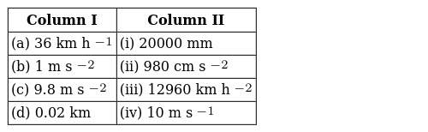  a) (a) - (iii), (b) - (ii), (c) - (i), (d) - (iv)  b) (a) - (i), (b) - (ii), (c) - (iii), (d) - (iv)  c) (a) - (ii),(b) - (i), (c) - (iv), (d) - (iii)  d) (a) - (iv), (b) - (iii),(c) - (ii), (d) - (i) | [1]
58 | The water drop falls at regular intervals from a tap 5 m above the ground. The third drop is leaving the tap at instant the first drop touches the ground. How far above the ground is the second drop at that instant? (Take g = 10 m S$​^{−2}$ )  a) 2.50 m  b) 1.25 m  c) 4.00 m  d) 3.75 m | [1]
59 | The diagram shows the velocity - time graph of two moving cars P and Q. The graph indicates that 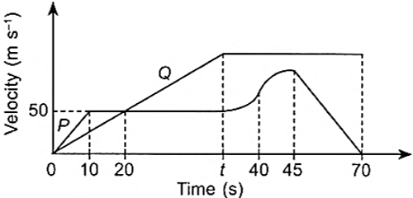  a) After 20 s, P is behind Q.  b) Car Q is moving with a constant acceleration from 0 to 40 seconds.  c) Acceleration of the car Q is not zero at any point during whole journey.  d) The velocity of car P is increasing at a decreasing rate from 40 s to 45 s in same direction. | [1]
60 | The area under the velocity - time graph gives the value of:  a) velocity  b) acceleration  c) mass  d) distance travelled | [1]
61 | Ifthe velocity of a body is reducing, it is said to have  a) Retardation  b) Both Negative acceleration and Retardation  c) Negative acceleration  d) Positive acceleration | [1]
62 | A body moves on three - quarters of a circle of radius r. The displacement and distance travelled by it  a) displacement = 0, distance =$\frac{3πr}{2}$  b) displacement = r, distance = 3r  c) distance = 2r, displacement =$\frac{3πr}{2}$  d) displacement =$\sqrt{2}r$ Distance = $\frac{3πr}{2}$ | [1]
63 | Find the correct statement:  - The SI unit of retardation is - ms$​^{−2}$  - The motion of the athletes is uniform  - Displacement is a scalar quantity  - Velocity has magnitude only  a) (B)  b) (A)  c) (D)  d) (C) | [1]
64 | Which of the following statement is correct?  - When a body starts from rest, u = 0  - When a body comes to rest, V = 0  - For a body under free fall,$a=−9.8m/s^{2}$  - For uniform velocity, a = 0  a) All of these  b) A and C  c) B and D  d) A, B and D | [1]
65 | Which of the following is a false statement?  - The body can have a constant velocity and still have a varying speed.  - The body can have zero velocity and still be accelerated.  - The body can have a constant speed and still have varying velocity  - The direction of the velocity of a body can change when its acceleration is constant.  a) (A)  b) (C)  c) (D)  d) (B) | [1]
66 | Which of the following is correct about uniform circular motion?  - The direction of motion is continuously changed.  - The direction of motion is not changed.  - Speed and direction both remain constant.  - Speed is constant, but the direction is changing.  a) (A) and (D) are correct  b) (B) and (C) are correct  c) All of these  d) (A), (B) and (C)are correct | [1]
67 | Which of the following is correct about uniform circular motion?  - The direction of motion is continuously changed.  - The direction of motion is not changed.  - Speed and direction both remain constant.  - D. Speed is constant, but the direction is changing.  a) A and D  b) B and C  c) All of these  d) A and C | [1]
68 | Which of the is true for displacement?  - It cannot be zero.  - Its magnitude is greater than the distance travelled by the object.  - It’s the shortest distance between initial & final position.  - It is a vector quantity.  a) A, Band Care correct  b) Aand Bare correct  c) All of these  d) Cand Dare correct | [1]
69 | Which of the following statements is correct?  - speed distance are scalar, velocity and displacement are vectors  - speed distance are vector, velocity and displacement are vectors  - speed and velocity are scalar, distance and velocity are vectors  - speed and velocity are vectors, distance and displacement are scalar  a) (D)  b) (B)  c) (C)  d) (A) | [1]
70 | Find the incorrect statement  a) The body is said to be accelerating if it moves in a uniform circular motion  b) None of these.  c) The slope of velocity - time graph gives instantaneous acceleration  d) When a body moves with constant speed its acceleration is zero | [1]
71 | Which of the following statement is correct?  - When a body starts from rest, u = 0  - When a body comes to rest, v= 0  - For a body under free fall,a = - 9.8m/s$​^{2}$  - For uniform velocity, a = 0  a) All of these  b) (B) and (C) are correct  c) (A) and (B) are correct  d) (A), (B) and (D) are correct | [1]
72 | Which of the following statements is not true?  - motion is always uniform  - motion is a change of position  - motion can be described in terms of displacement  - ​​​​​​​motion can be uniform or non - uniform  a) (B)  b) (A)  c) (D)  d) (C) | [1]
73 | Starting from rest at the top of an inclined plane a body reaches the bottom of the inclined plane in 4 seconds. At what time does the body cover one fourth the distance starting from rest at the top?  a) 3 second  b) 2 second  c) 1 second  d) 4 second | [1]
74 | A particle accelerates from rest at a constant rate for some time and attains a constant velocity of 8 ms$​^{−1}$ . Afterward, it decelerates at a constant rate and comes to rest. If the total time taken is 4 second, the distance travelled is:  a) 32 meter  b) 16 metre  c) 4 metre  d) insufficient data | [1]
75 | A car travels 100 km east and then 100 km south. Finally, it comes back to the starting point by the southeast route. Throughout the journey, the speed is constant at 60 km h$​^{−1}$ . The average velocity for the whole journey if the time taken is 3.3 hours is  a) 90 kmh$​^{−1}$  b) 60 kmh$​^{−1}$  c) 180 kmh$​^{−1}$  d) 0 kmh$​^{−1}$ | [1]

